**Problem Statement**

Create a dynamic PHP web page that changes its content based on user selection using control statements (specifically, switch-case).

**Steps Taken**

1. **Initialize Default Variables**:
   * Set a default variable $page to "home" to display the home page initially.
2. **Form Handling**:
   * Check if the form has been submitted using isset($_POST['page']). If a page is selected, update the $page variable with the submitted value.
3. **HTML Structure**:
   * Created the HTML layout with sections for the header, navigation, main content, and footer.
4. **Navigation using Form Buttons**:
   * Added a form in the navigation area containing buttons for each page (Home, About, Services, Contact). Each button submits the form with its respective value using the POST method.
5. **Display Content with Switch Statement**:
   * Used a switch control statement to determine which content to display based on the value of the $page variable:
     + **Case "home"**: Displays the home page content.
     + **Case "about"**: Displays the about page content.
     + **Case "services"**: Displays the services page content.
     + **Case "contact"**: Displays the contact page content.
     + **Default Case**: If none of the cases match, it defaults to the home page content.
6. **Dynamic Footer**:
   * The footer dynamically displays the current year using date("Y"), ensuring that the copyright notice is always up to date.

**Conclusion**

This PHP program effectively demonstrates the use of control statements to create a dynamic web page. The content changes based on user interaction with the form, allowing for a seamless navigation experience across different sections of the website.

**Output:**

**1.**

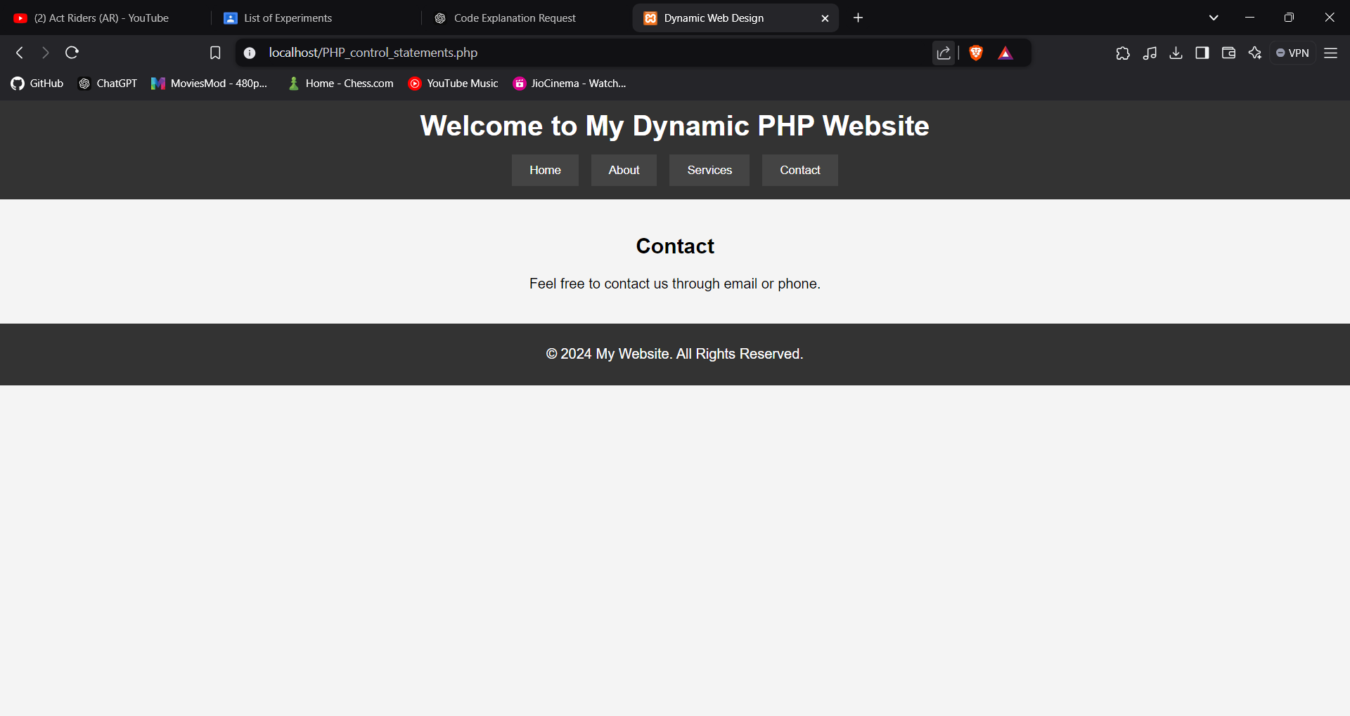

**2.**

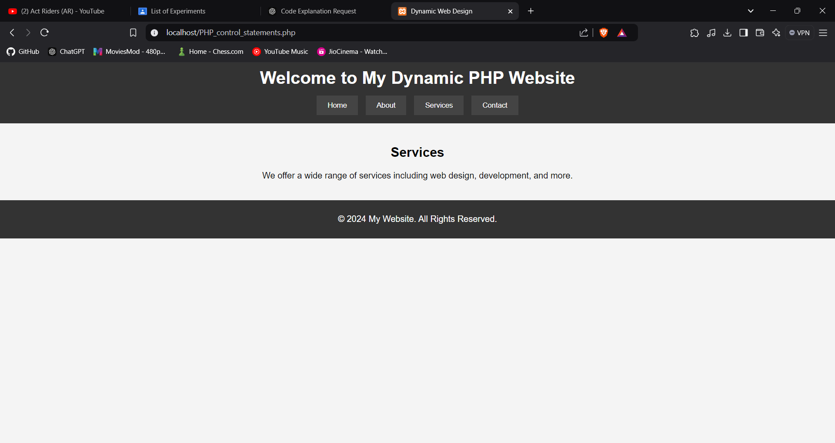

**3.**

